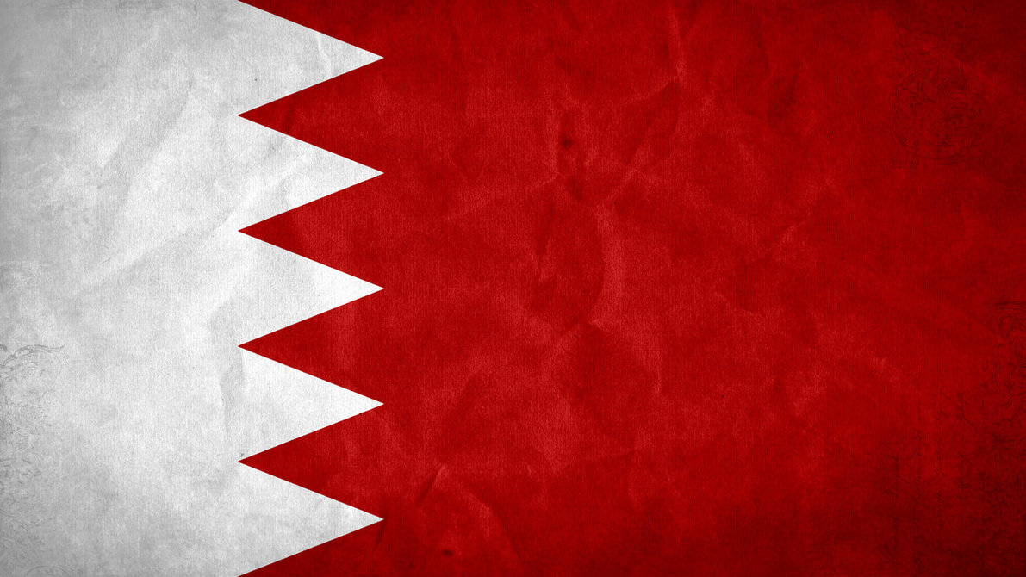
Bahrain

Bahrain is a small dot on the world map
It is quite unknown by half the world
Looking for it in google maps you need to tap
Most people call it an island or a country
Leaving the house without a sun hat cap
The sun heat will give a tourist a stroke
That is because the summers are very high
And the winter temperatures very low
The climate can never be understood
One day the sand storms fill up everywhere out
One day the humidity wets your t-shirt
They call her Bahrain for two reasons
It means two seas in the Arabic world
And Bahrain has only the top two seasons

