
Love

This thing was a bizarra hitting feeling
My silly heart was a flower peeling
Because I had it held in a state of lock

My distracted mind had no words to say
It was important to keep the chat on
I felt that today was my lucky day
This new feeling was very uncommon

It was the start of that nice feeling
That day I never felt the way I felt
My heart will not accuse her for stealing
Love was the action that is dealt

She is my source of true happiness
God is the only person to witness

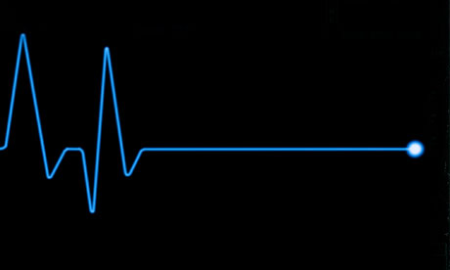
Death

We will all go through that road
The feeling tickles every part of the body
Hearing about death is sour on the throat
He can come down and kill anybody

In a black coffin in the town church
The father blesses you with his prayer
Your sad family will have the final touch
Down to the yard down to the death slayer

Here comes the time to pay for your life heart
Your actions are recorded and given to god
Here comes the angels down with their life charts
It has all your life sins and all your goods

Life is too short you never know at what time
So you better stop doing all your crime


Beauty

Her face from far was not very clear
Her hair was blowing from the wind
As she came in I had to stare
Beauty was all that came in my mind
Her face was shining like a star
Her shine made my eyes seem like blind

Thinking of her inner beauty
Out beauty is just a cover
Personality should be sweetie
Her words should be the big answer
Sexiness should not be naughty
Attitude defines beauty better

Looking at her beauty at whole
My mind was running crazy
Beauty comes from the soul
Her beauty feels like a daisy
Beauty is a very long life goal
Perfecting it makes you very busy

