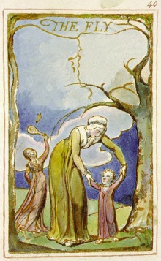
The time was passing fast
Surviving from the fly was a hard test
‘Cause the bug was very near
The exam for me was unclear.
My sweat fell on my math test
I was hoping for the best
The fly kept buzzing around me
Other than the fly I cannot see.
Hearing the fly buzz high
I felt his time had come to die
My greatest fear was that fly alive
I could not do anything because it had arrived.
As I sat in the exam hall
And I forgot about the mall
As I got my exam paper
It was as tough as a rapier.
Beginning to write my name
I started to feel the shame
Then came the fly flying
Then came my state of dying

